Personal Expense Tracker web application (Budgetly)

.NET TECHNOLOGY (01CE0523)

MINI PROJECT REPORT

Submitted by:
Enrollment : 92301703072 | Student Name : Komal Kumari

BACHELOR OF TECHNOLOGY
in

Computer Engineering



Marwadi University, Rajkot

November, 2025

.NET Technologies (01CE0523)
Mini Project
Faculty of Technology, Marwadi University
Computer Engineering Department
2025-26

CERTIFICATE

This is to certify that the project report submitted along with the project entitled Personal Expense Tracker web application (Budgetly) has been carried out by Komal Kumari (92301703072) under my guidance in partial fulfillment for the degree of Bachelor of Technology in Computer Engineering, 5th Semester of Marwadi University, Rajkot during the academic year 2025-26.

Sign: Sign:

Prof. Priyanka Mangi Dr. Krunal Vaghela

Internal Guide Head of the Department

Index
Acknowledgments i
Abstract ii
- Introduction 1
- Technology used and Implementation Strategy 3
- Implementation Snapshot 5
- Conclusion 12
References 13

Acknowledgments

This mini project would not have been possible without the Guidance and the help of several Individuals who in some ways contributed their valuable time and assistance in the completion of this Internship.

I would like to thank my college Marwadi University for giving us this opportunity of doing Internship and gaining Industry Level Experience in the field that I are interested in. My sincere gratitude to our Head of The Department (HOD), Dr. Krunal Vaghela, my Internal Guide, Prof. Priyanka Mangi for helping and solving our queries whenever required.

Abstract

The Expense Tracker web application is a personal finance management tool developed using ADO.NET, SQL Server, ML.NET , and ASP.NET Web Forms (C#). It helps users efficiently track their income, expenses, and budgets, while also providing intelligent predictions and insights through integrated machine learning. The application allows users to monitor their spending patterns, set financial goals, and analyze their performance using visually interactive dashboards and charts. By integrating ML.NET, the system introduces data-driven forecasting capabilities for future expense predictions. This project demonstrates the combined use of traditional ADO.NET database operations with modern ML-based analytics in a secure and user-friendly environment.

Introduction

In today’s fast-paced digital world, managing personal finances is no longer a luxury it’s a necessity. From online shopping and digital subscriptions to utility bills and daily coffee runs, money moves faster than ever before. Yet, many individuals still rely on manual tracking or fragmented mobile apps that don’t truly help them understand their financial behaviour. This challenge inspired the creation of the Expense Tracker, a smart, web-based application designed to simplify financial management through intelligent automation and insightful analytics.

The Expense Tracker goes beyond being just another spending log. It is designed to act as a personal finance assistant, helping users take control of their income, expenses, and budgets all in one place. Users can record every transaction, categorize their expenses, and visualize how their money flows each month. The system transforms simple financial data into meaningful insights, giving users a clear picture of their habits and helping them make more informed financial decisions.

Built using ASP.NET Web Forms (C#) and SQL Server, the application combines the reliability of Microsoft’s web technologies with the flexibility of modern design. The backend leverages ADO.NET for efficient and secure data handling that manages everything from user authentication to data visualization. Each entry, whether income or expense, is securely stored and can be retrieved or analysed instantly, ensuring a smooth, consistent user experience. The modular design also makes the system scalable, allowing new features or analytics modules to be added with ease.

What truly sets this project apart is its integration of ML.NET, Microsoft’s powerful machine learning framework. Instead of merely recording data, the system learns from it. By analysing historical income and expense patterns, it predicts future spending trends, identifies potential overspending areas, and helps users plan better. For example, if the model detects a rise in certain categories say, entertainment or dining it can forecast future spending and alert the user before they exceed their budget. This feature transforms a static expense log into a proactive financial advisor.

Visually, the application features an interactive dashboard that displays summaries, charts, and heatmaps, making it easy to spot trends at a glance. Color-coded visuals and intuitive navigation provide a seamless experience that appeals to both casual users and tech enthusiasts.

In essence, the Expense Tracker project demonstrates how technology, data, and machine learning can work together to empower everyday financial awareness. It’s not just about tracking where your money went it’s about predicting where it’s going next. By blending practical functionality with intelligent forecasting, the project brings a new level of engagement and usefulness to personal expense management in the digital age.

Technology used and Implementation Strategy

Technology Used :

Technology / Tool | Purpose
ADO.NET | Data access layer for database connectivity, commands, and transactions
SQL Server | Relational database for storing user, income, expense, and budget data
ASP.NET Web Forms (C#) | Core framework for building dynamic web pages and handling server-side logic
ML.NET | Machine learning library for implementing expense prediction models
HTML, CSS, JavaScript | Frontend structure, design, and interactivity
Chart.js | Dynamic visualization for budget and expense charts
Bootstrap / Custom CSS | Responsive UI design and consistent styling
Visual Studio 2022 | IDE for building, debugging, and deploying the project
Session Management | Ensures user authentication and personalized experience

Implementation Strategy

- Database Design
  - Tables include: Users, Income, Expense, and Budget.
  - Primary–foreign key relationships maintain data consistency.
  - Queries optimized using ADO.NET SqlCommand, SqlDataReader, and SqlDataAdapter for efficient CRUD operations.

- Backend Implementation
  - Built with ASP.NET Web Forms (C#) using code-behind architecture.
  - Server-side logic handles authentication, data validation, and financial calculations.
  - Integration with ML.NET enables predictive analytics for future expenses based on past user data.

- Frontend Design
  - A dashboard-driven UI with sidebar navigation, similar to modern finance platforms.
  - Clean visual hierarchy using custom CSS and responsive layouts.
  - Charts and heatmaps powered by Chart.js.

- Machine Learning Integration
  - Uses ML.NET regression models to analyse historical expense data.
  - Predicts upcoming month’s spending based on past spending trends.
  - Displays predictions in the “Advance (ML)” section for visual comparison.

- Core Functional Modules
  - Dashboard: Visual summary of financial status, including heatmaps and charts.
  - Expense Module: Records all spending with date and category.
  - Income Module: Logs all incoming money sources.
  - Budget Module: Sets monthly limits and compares actual spending.
  - Reports & ML Section: Generates reports and predicts future spending patterns.

- Security & Data Handling
  - Session-based user authentication.
  - Input sanitization and parameterized SQL queries to prevent SQL injection.
  - Layered architecture ensures maintainability and scalability.

Implementation Snapshot

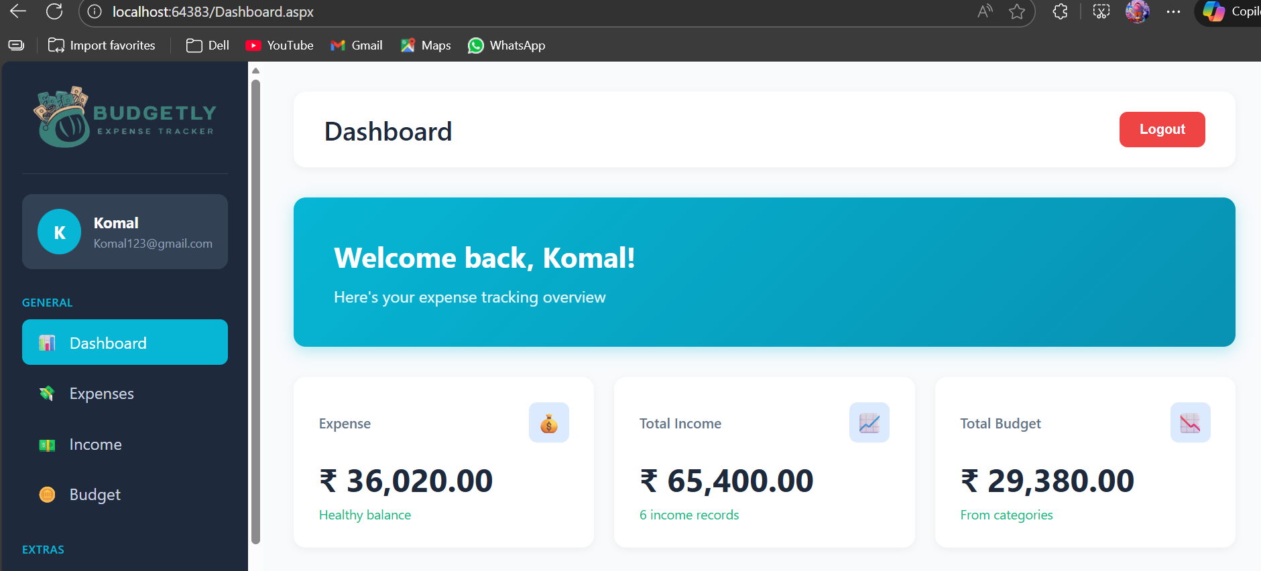
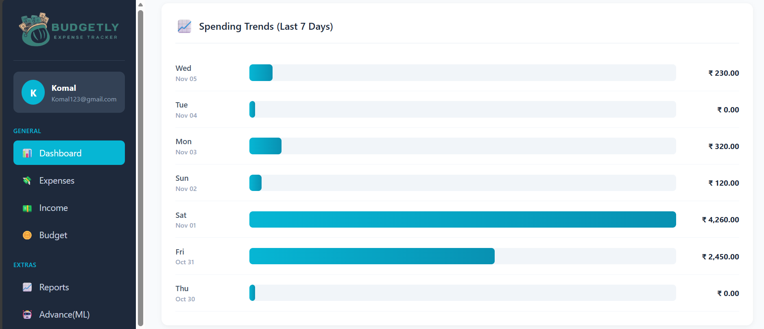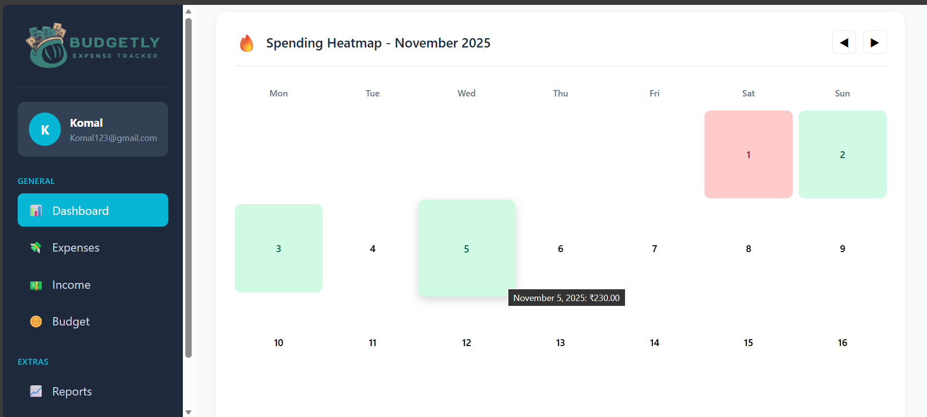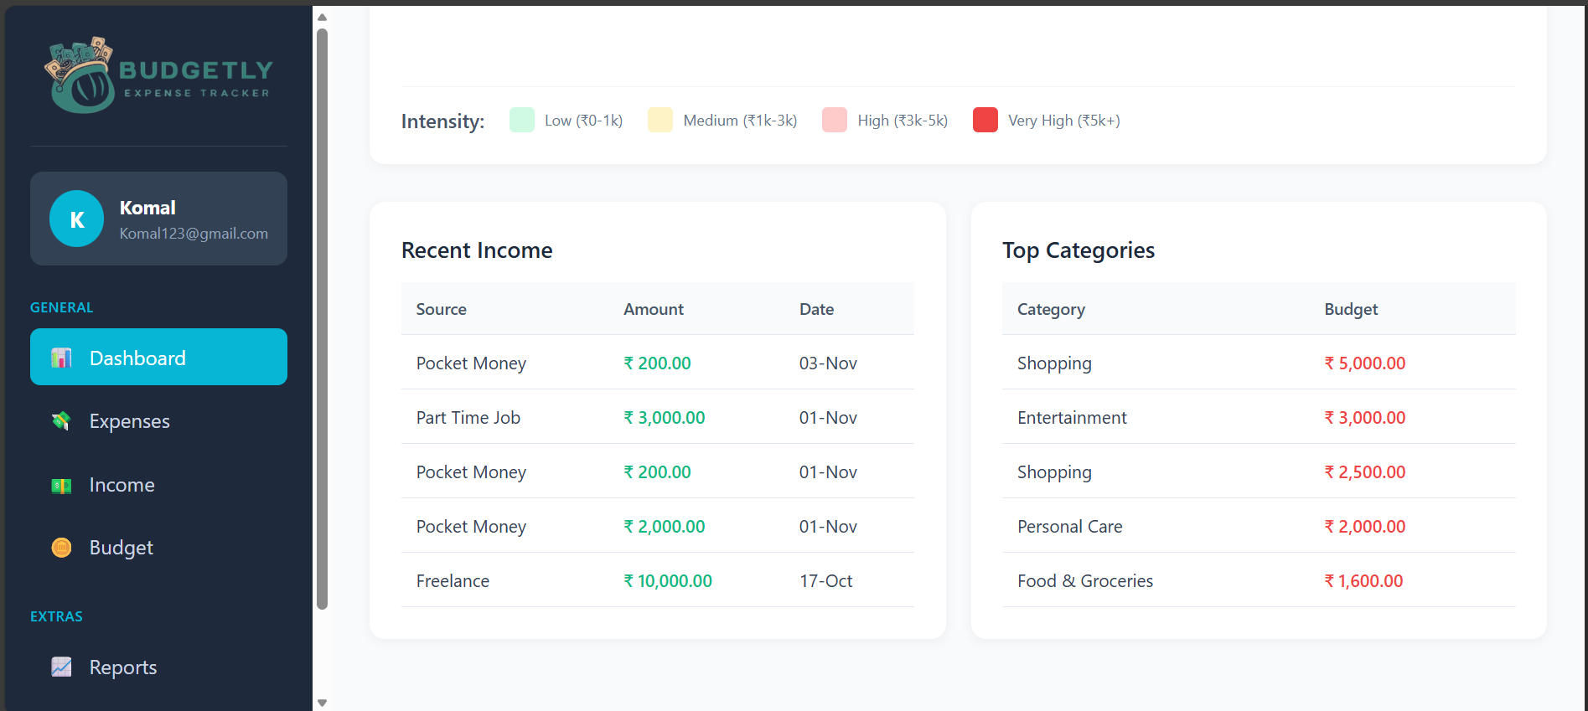
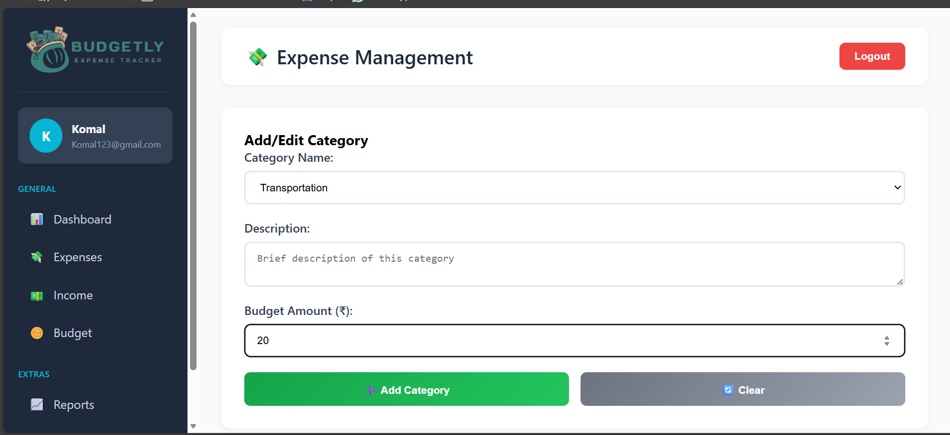
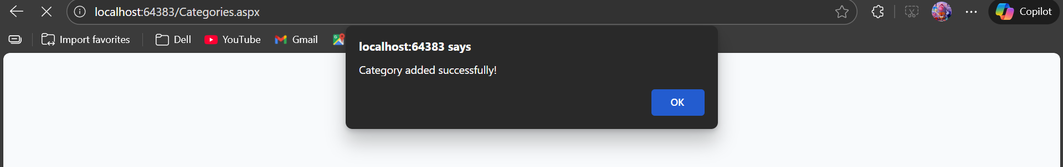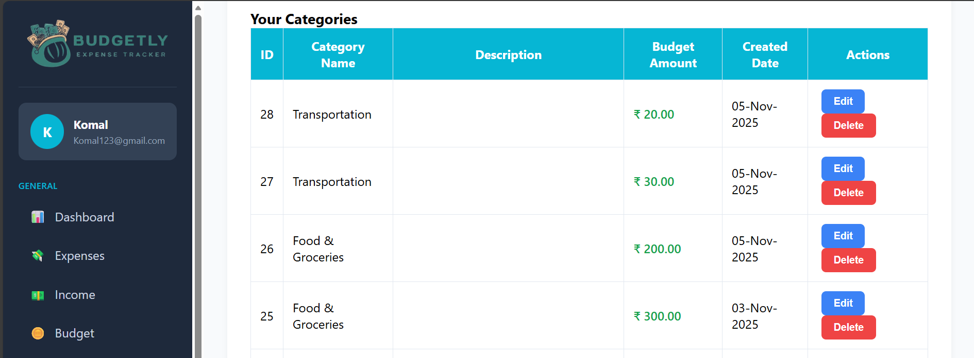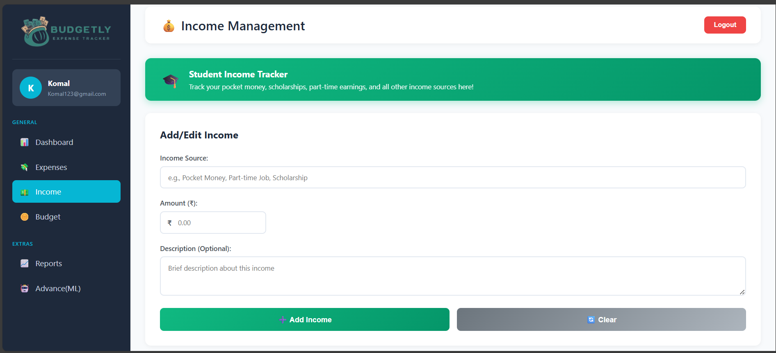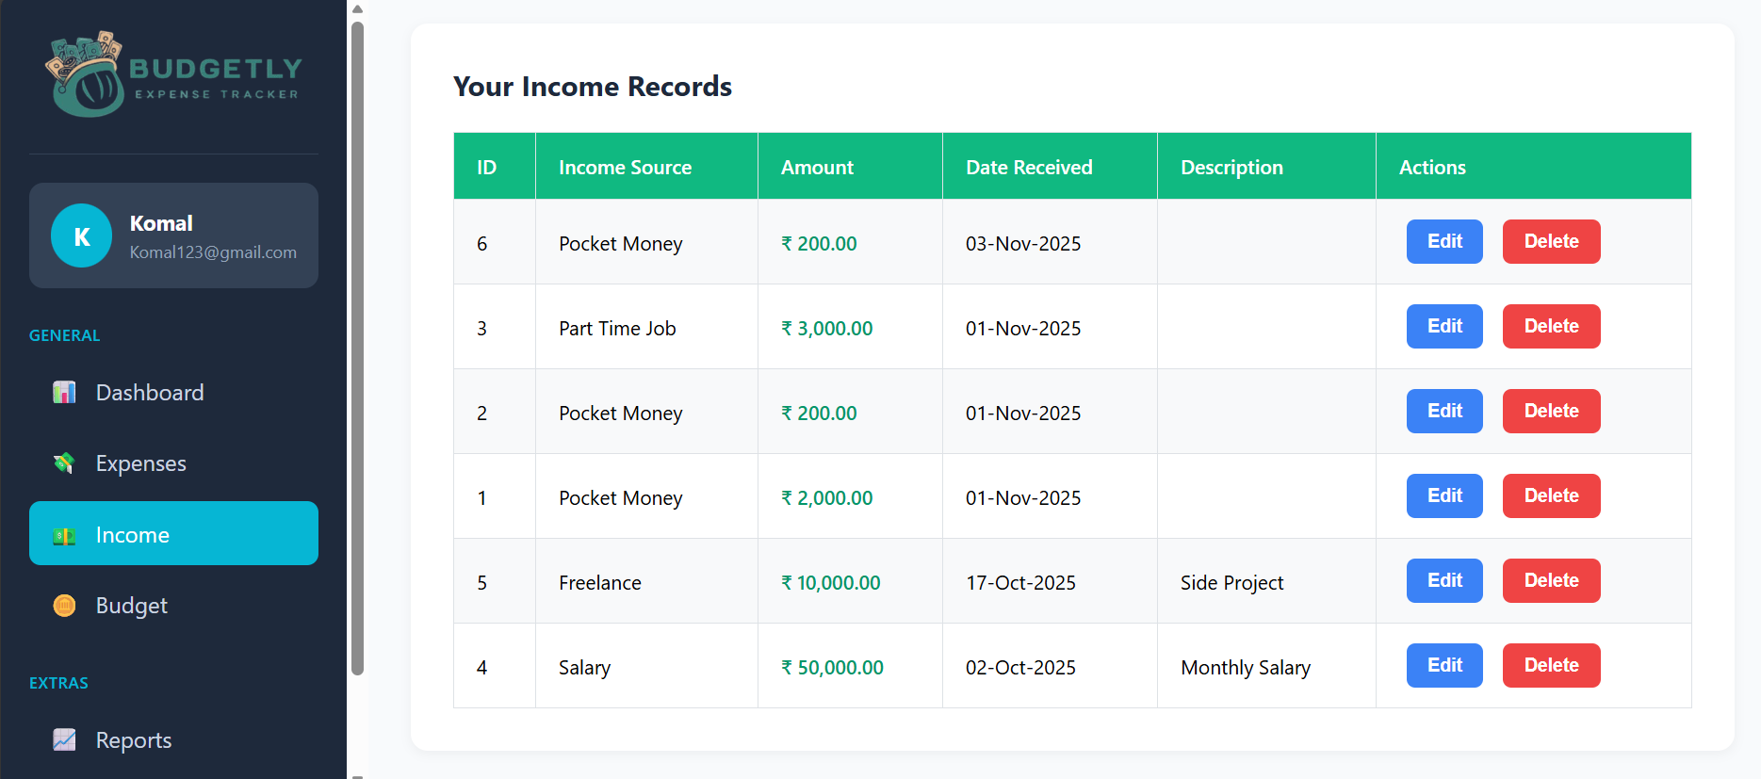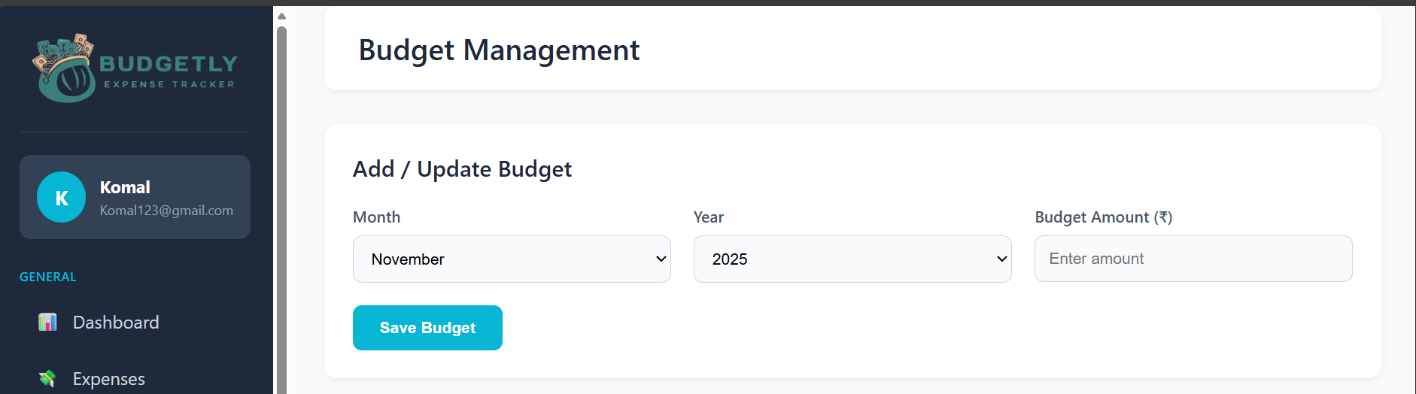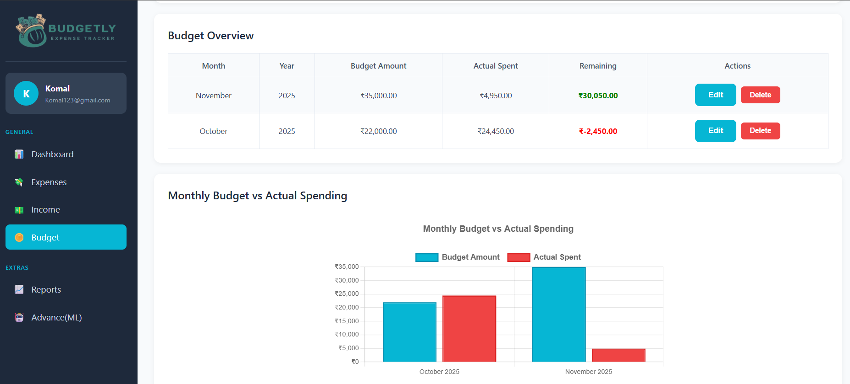
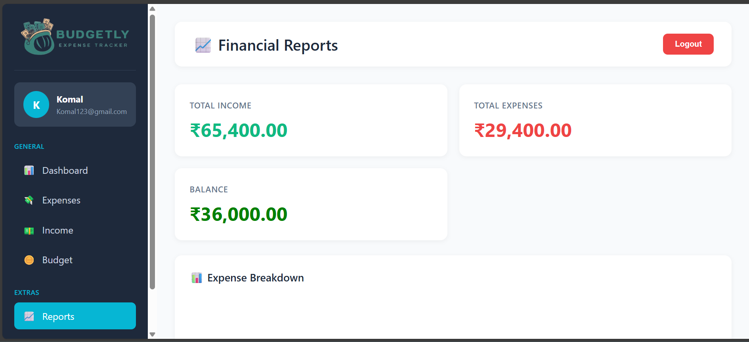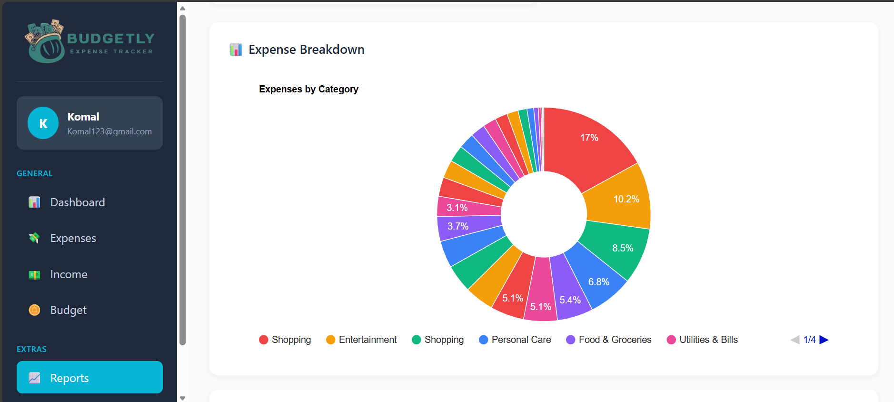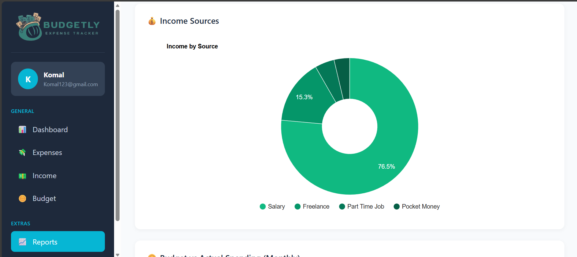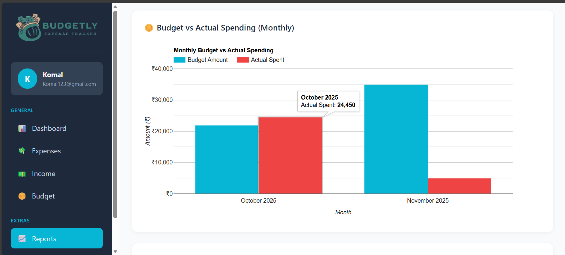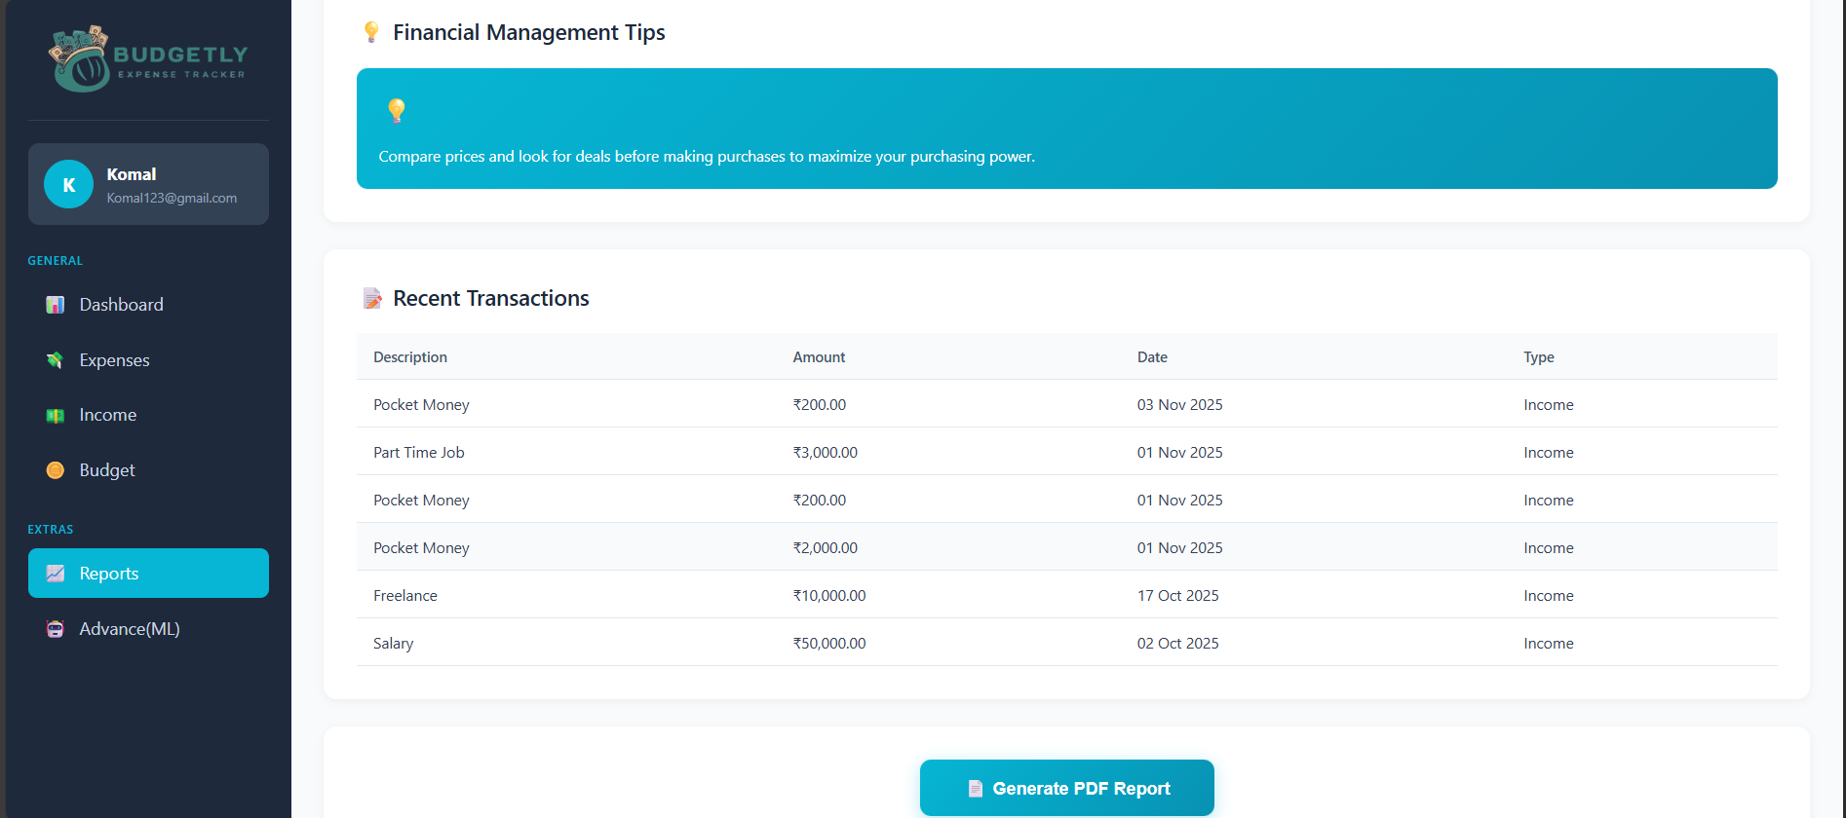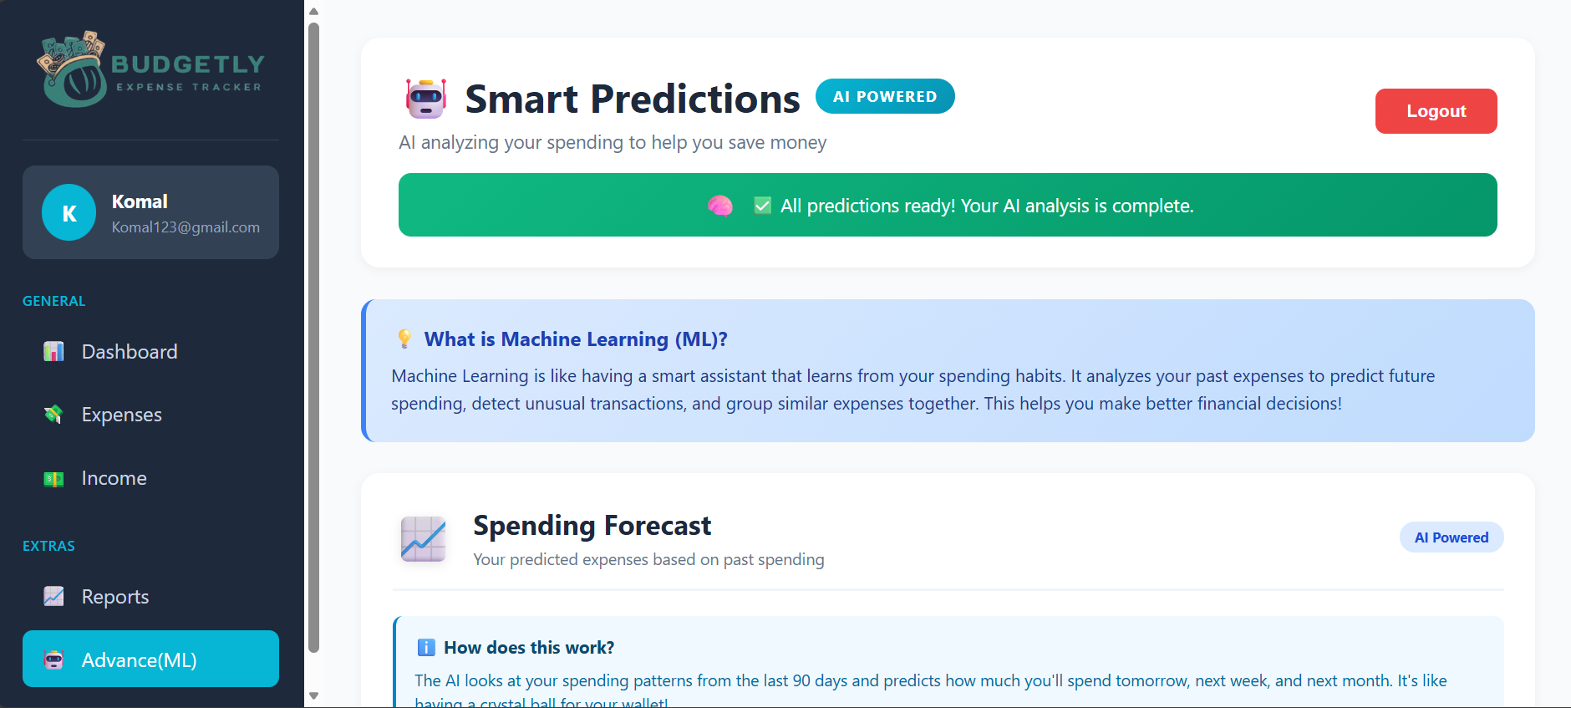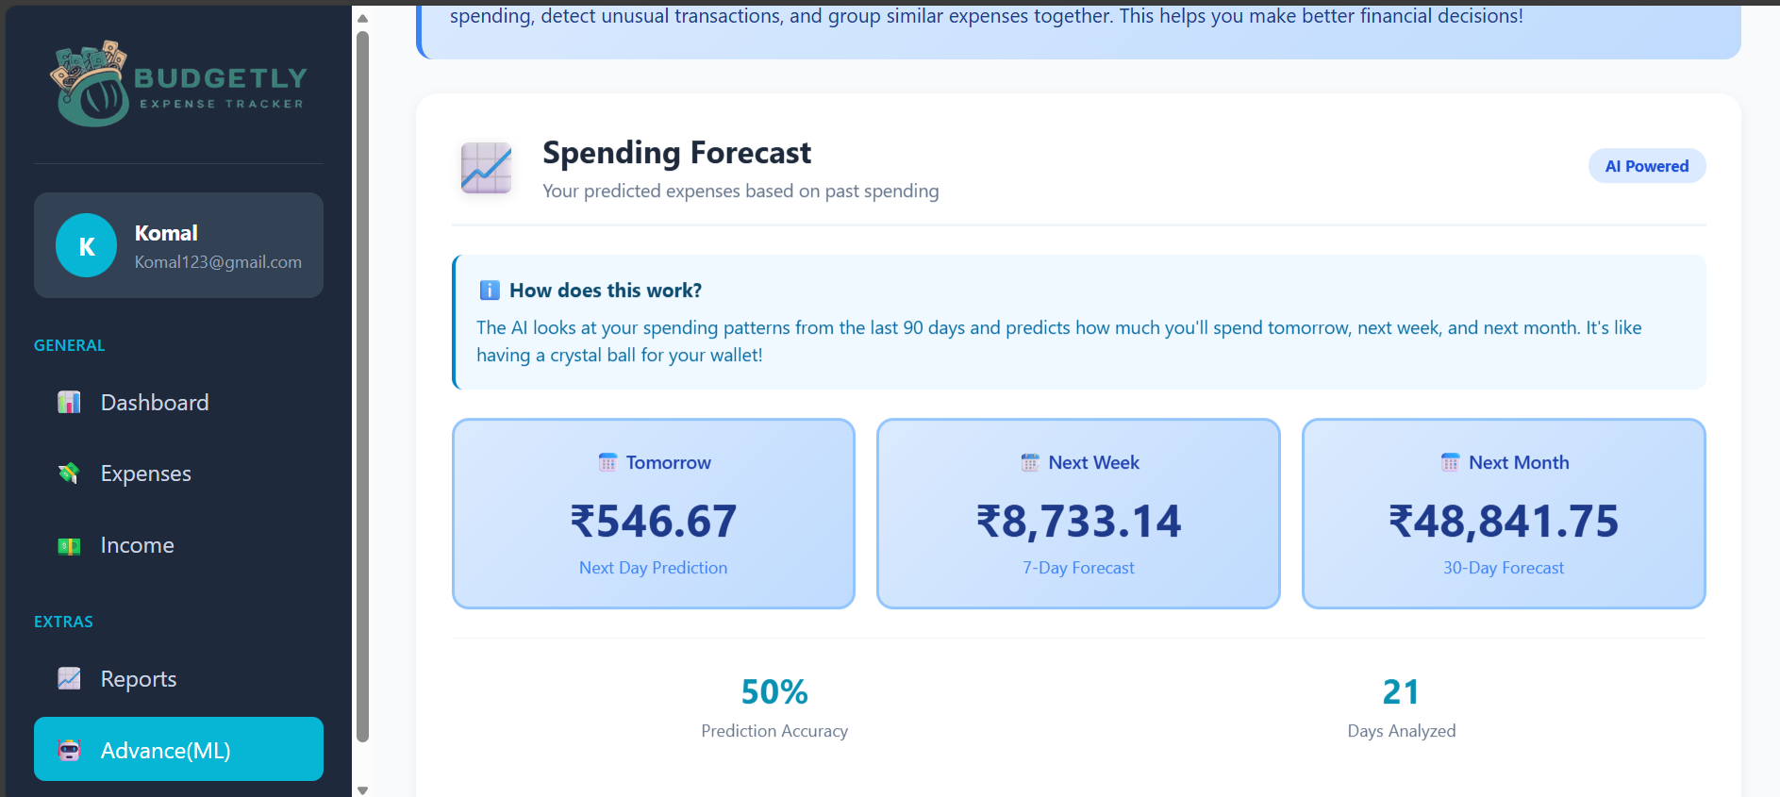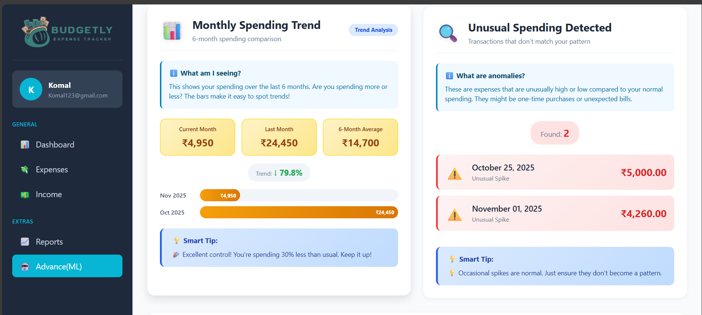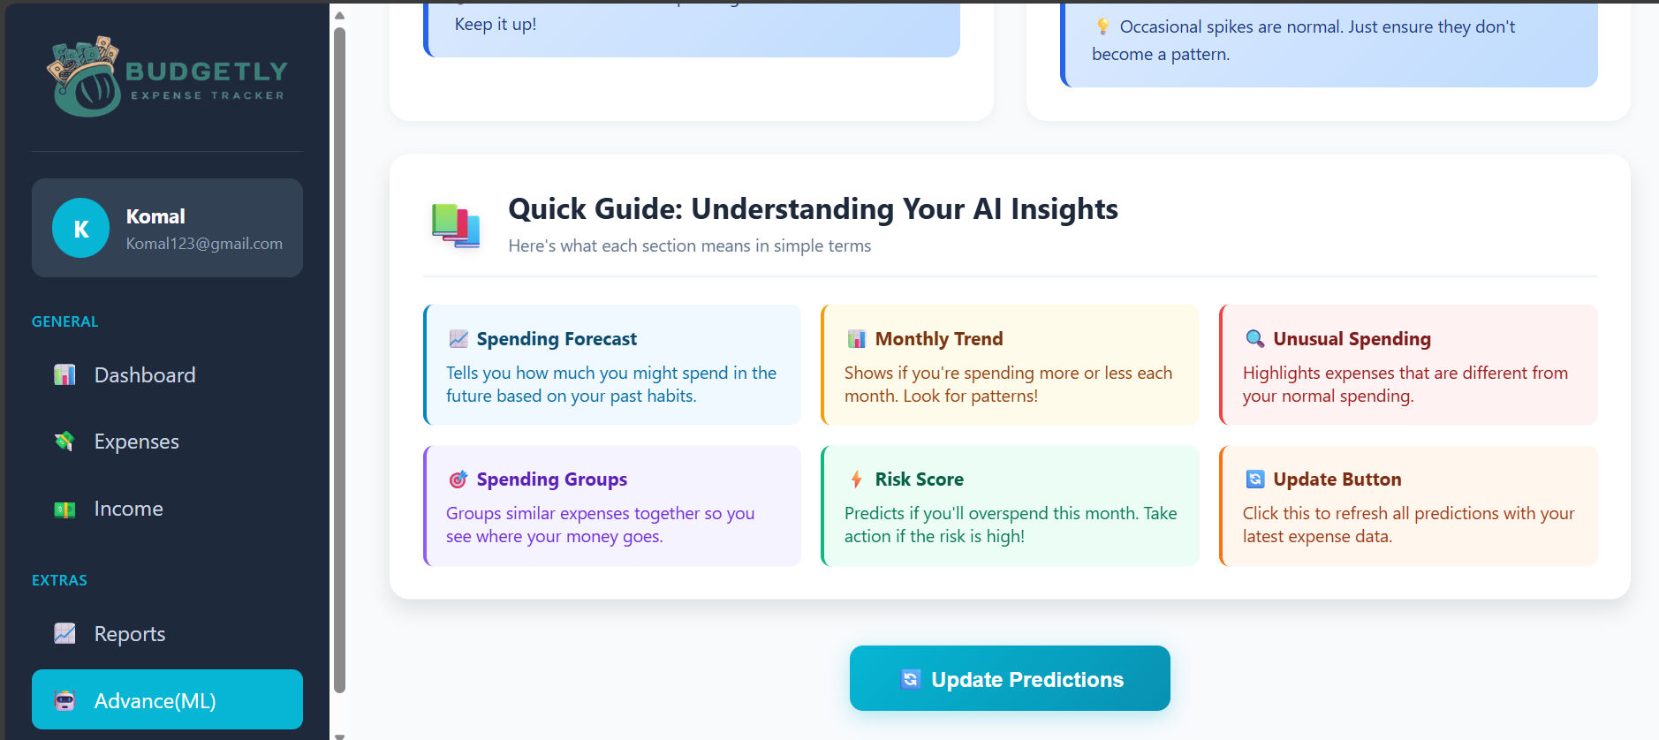

4. Conclusion

The Expense Tracker project successfully integrates data-driven financial management with modern machine learning predictions. By combining ASP.NET Web Forms, ADO.NET, and ML.NET, the application provides a complete ecosystem for personal finance — from daily expense tracking to smart forecasting.

It enables users to not only view their financial activities but also anticipate future spending trends, helping in better planning and decision-making. The modular and scalable design ensures adaptability for future enhancements such as mobile integration, real-time notifications, and cloud-based data synchronization.

References

- Srikanth Technologies – ADO.NET CRUD Operations Tutorial.
https://srikanthtechnologies.com/blog/dotnet/adonetcrud1.aspx

- CodAffection – Expense Tracker Using ASP.NET Core MVC
https://github.com/codaffection

- BudgetWise – Personal Finance Web App (.NET 8)
https://github.com/someuser/BudgetWise

- sandesh300 – ASP.NET Core MVC Expense Tracker
https://github.com/sandesh300

- ExpensAce – ASP.NET Core MVC Expense Management System
https://github.com/someuser/ExpensAce

- Syncfusion Showcase – ASP.NET Core Dashboard Demos
https://github.com/syncfusion

- Expensify – Personal Expense Management Platform
https://www.expensify.com

